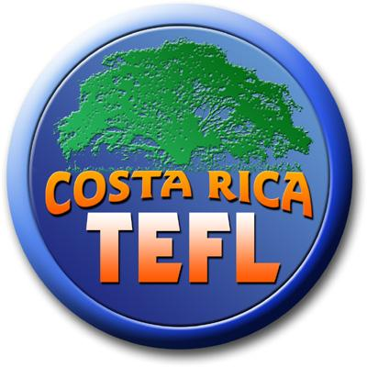

Costa Rica TEFL Application Form
Sámara Beach, Costa Rica
Please complete the application and send it to info@costaricatefl.com.

Course Dates: Date of application:

Location: Accommodations needed: yes • no •

First Name: Last Name:

Date of Birth: Male ⃞ Female ⃞

Country of origin: First Language:

General Health: Medical Conditions:

Present Occupation:

Home Address: Phone Number/s:

Email: Emergency Contact: (name and number):

Where did you hear about us?
• Google • GoOverseas.com • World of TEFL • Facebook
• TEFL Course Review • SamaraBeach.com • Other ___________
• Friend/Relative, Name ____________________

General Education:

- Higher Education (include University/College name, degree and graduation dates as well as any relevant courses taken)

- Other relevant qualifications/certificates etc.:

Language:
Please provide information on languages you speak/read/write/understand and your level of proficiency:

Provide information on your experience learning a language:(ex: Where?, How?)

Work or Voluntary Experience:

Do you have any formal or informal tutoring or teaching experience? If yes, in what subject areas? Provide details.

Do you have any formal or informal experience teaching a language? If yes, how many months/years?

What other work or volunteer experiences do you have that may contribute to your performance
in the classroom?

How do you characterize yourself as a learner?

What style of learning works best for you? (ex: visual, audio, kinesthetic etc.)

How would you get students involved in a language class?

Why do you think you are suited for language teaching?

Think about your experience being taught in either the traditional or communicative approach. What was the result of your learning experience? Give details please.

